Output Of Automate At Web Application

1.When we run our program

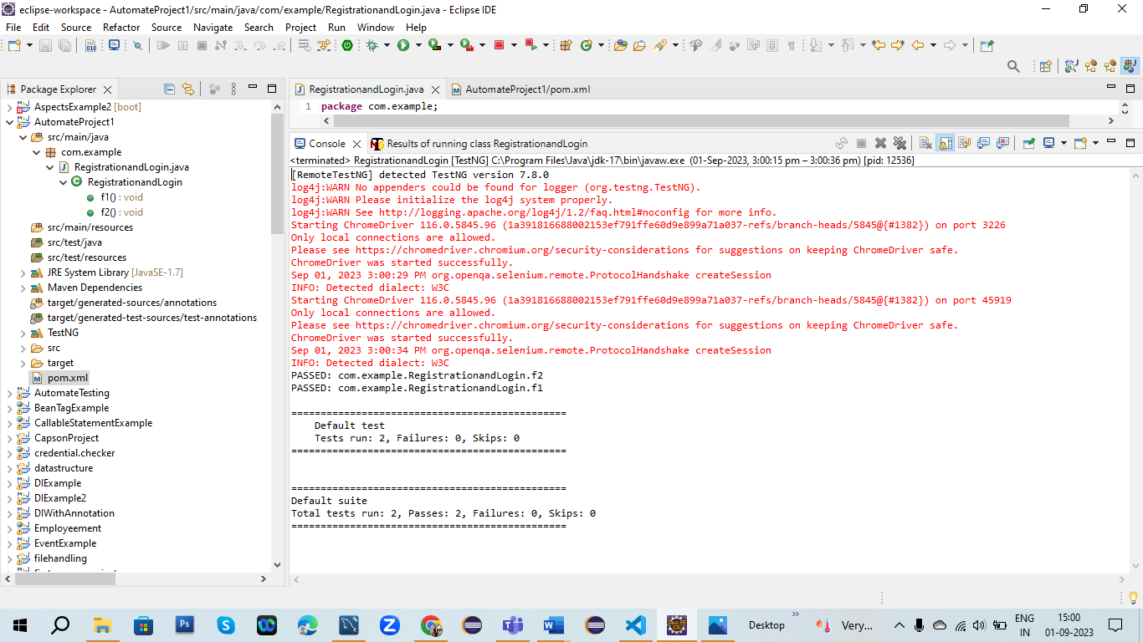

2.When we check the login apge and Registration Page

